Important slides

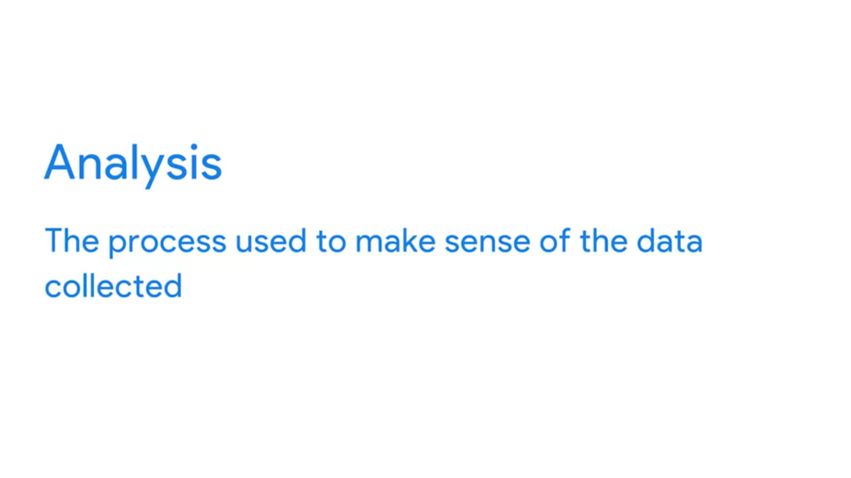



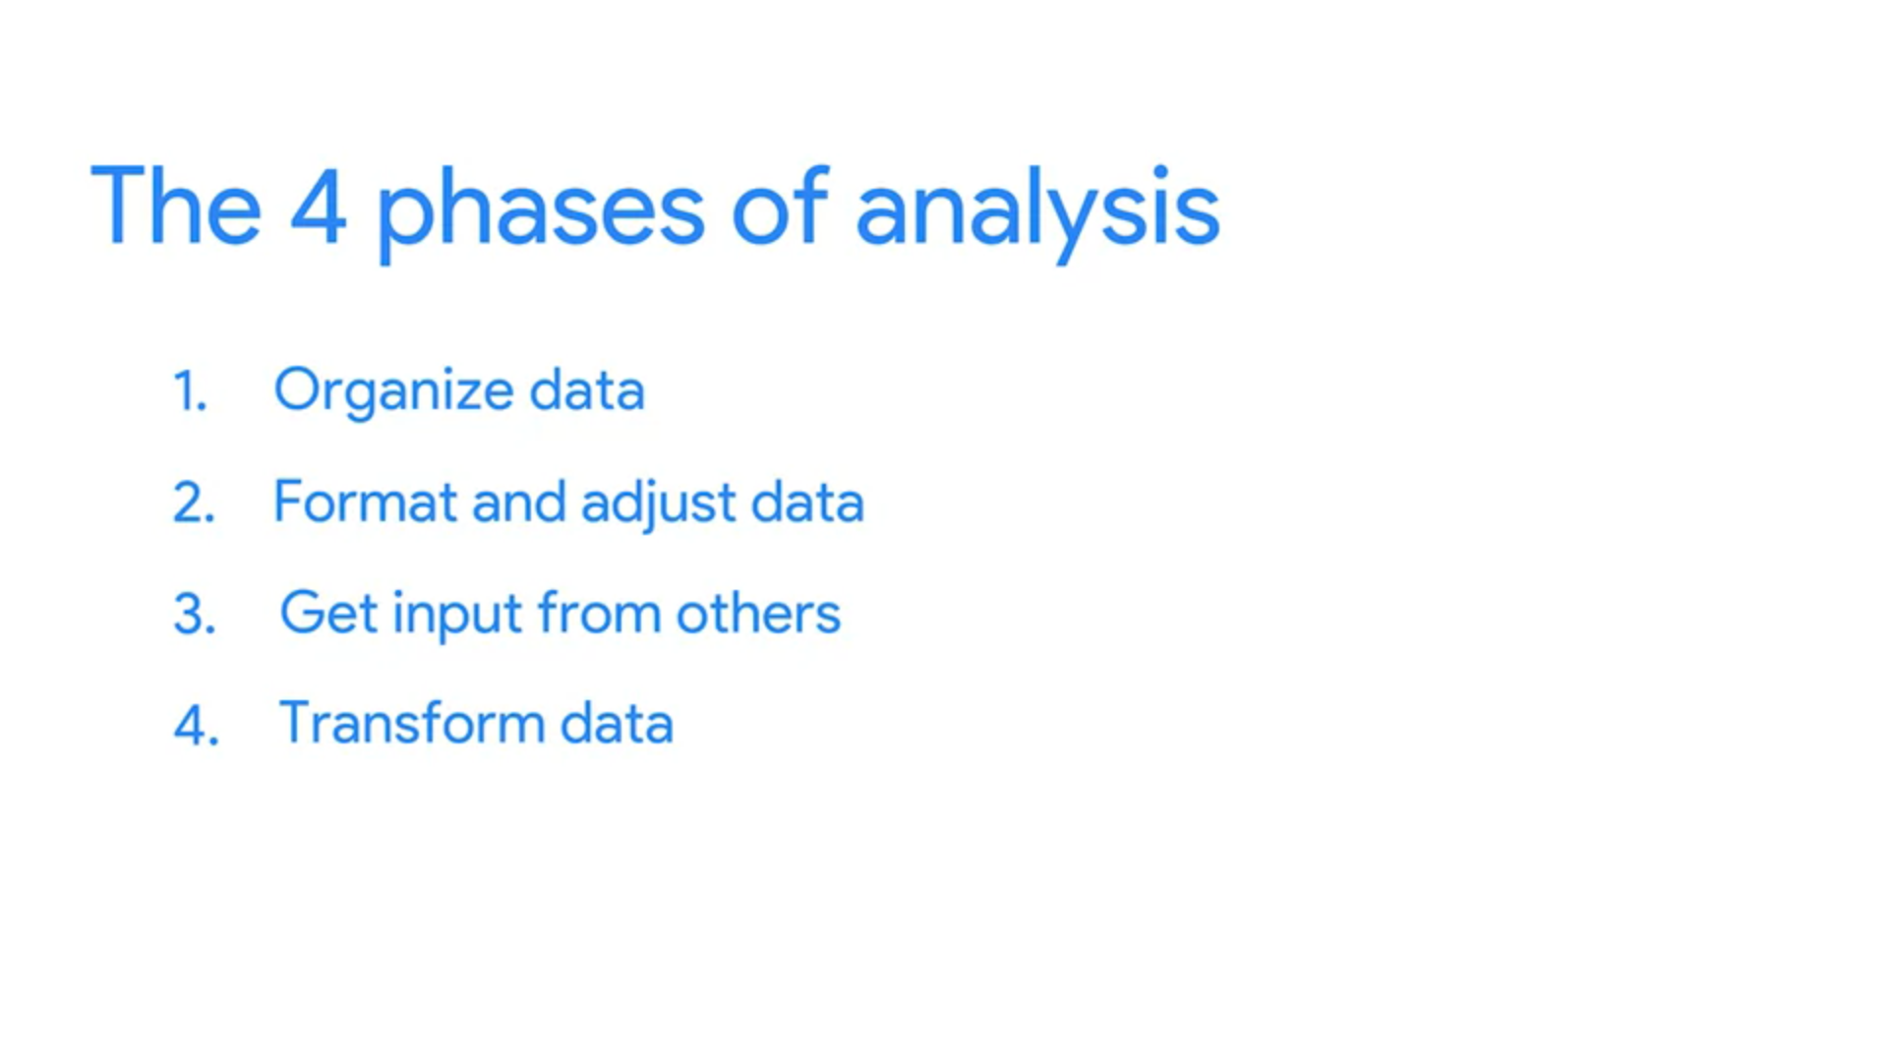

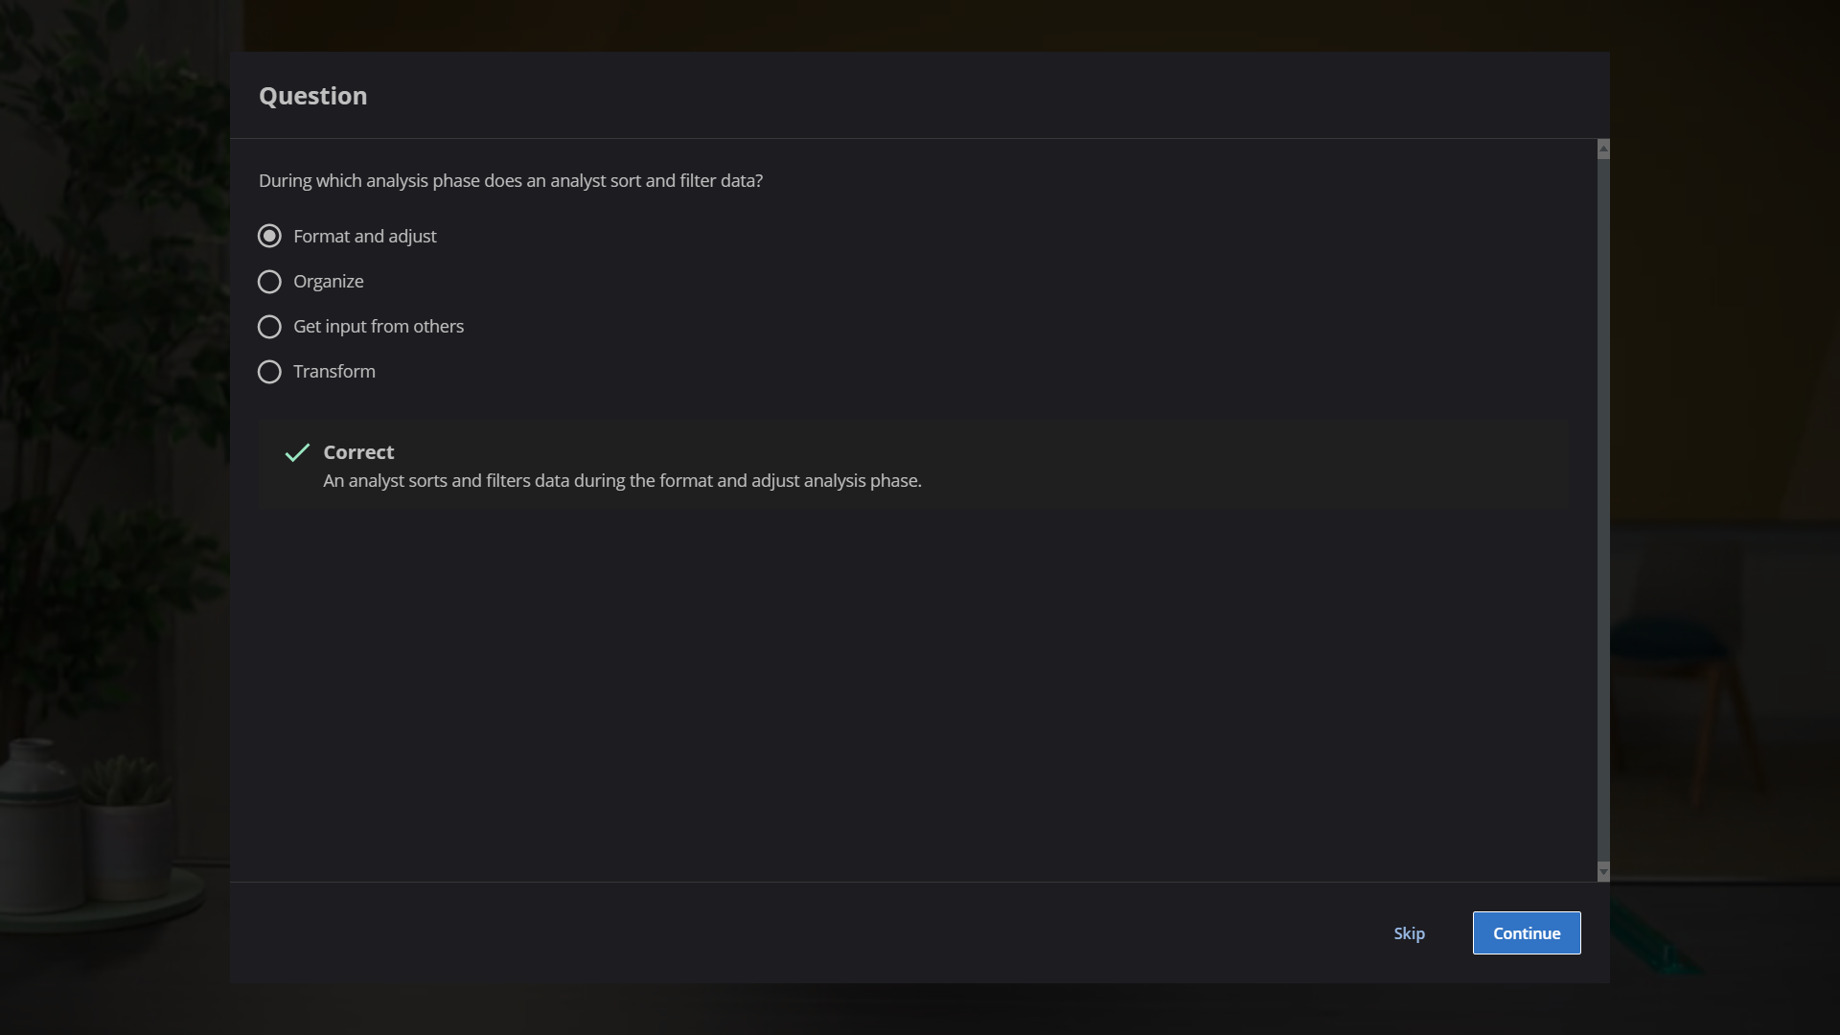

Organize data for analysis

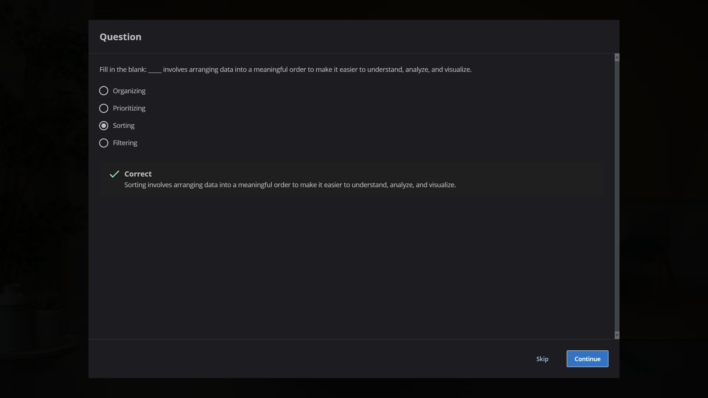

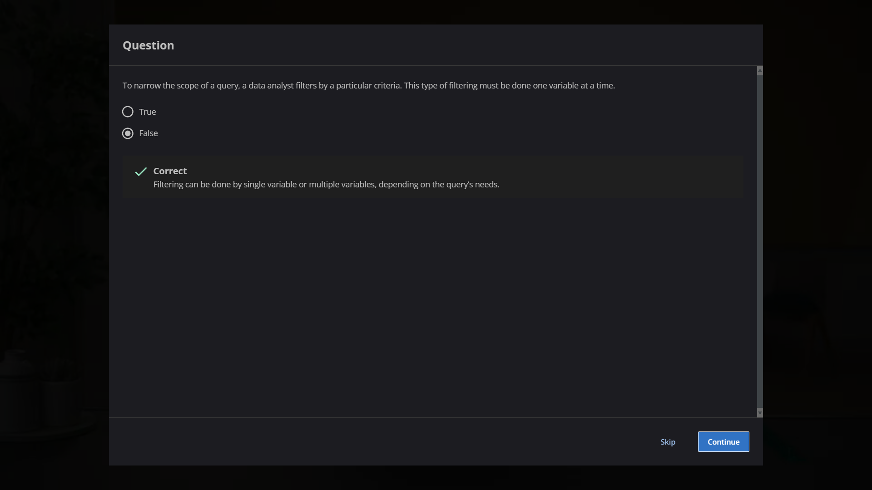

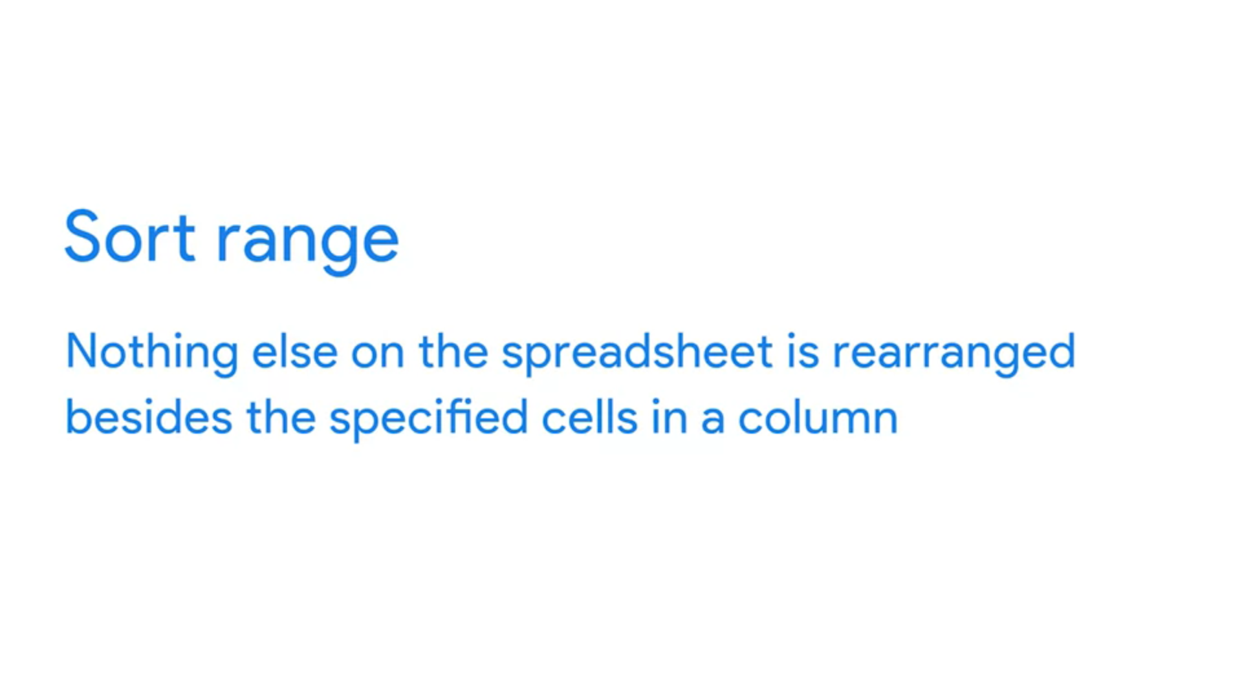

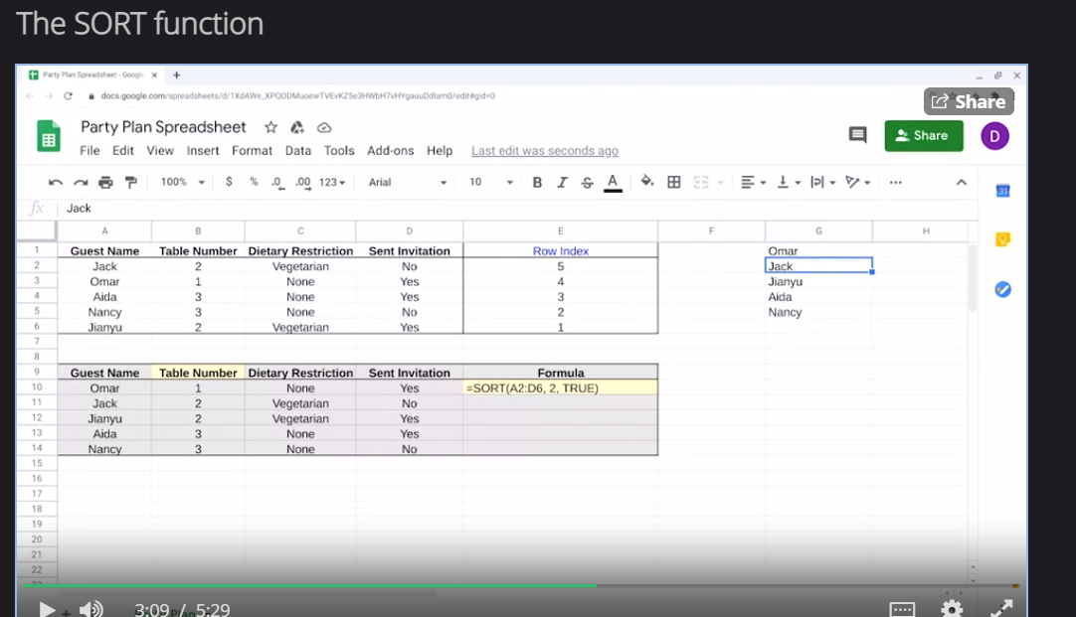



Which of the following statements accurately describe the difference between a menu sort function and a written SORT function?

A menu sort function changes the data, while the written SORT function rearranges it.

A menu sort function rearranges the data, while the written SORT function rewrites it.

A menu sort function sorts data permanently, while the written SORT function only sorts it temporarily.

A menu sort function rearranges the data, while the written SORT function changes it.

**Correct**

A menu sort function rearranges the data, while the written SORT function changes the existing data.

Skip

Continue